**Protocol: inForm 2.4.1 Phenotype (Onesies)**

1. Launch inForm Cell Analysis®
2. Open correct library algorithm
   1. Go to file 🡪 Open 🡪 Algorithm
3. Open im3 files
   1. Go to file 🡪 Open 🡪 Algorithm
   2. If opening on the VM do not save anything to the local computer. If opening on a desktop then it is advisable to save images to the local computer.
   3. Select 3 to 5 images per case you are analyzing, up to a total of about 25 images. Ensuring you select fields that are diverse.
      1. Select fields that make sense for the analysis
4. Configuring a Project
   1. Select [Configure…] at the top, and select [No] when prompted to save your project.
   2. Select the following
      1. Trainable Tissue Segmentation
      2. Adaptive Cell Segmentation
      3. Phenotyping
      4. Export
   3. Name the Antibodies by selecting the ‘Edit Markers and Colors‘ box on the ‘Prepare Images’ tab
      1. These names should correspond to the names defined in the ‘Target’ column of the BatchID file. The tumor marker, as indicated in column 14 (‘ImageQA\QC’) of that file, can be replaced with ‘Tumor’
      2. use ‘DAPI’ for the name of DAPI and AF for auto fluorescence
5. Segment Tissue Trainable Tissue Segmentation utilizes a computer learning algorithm over a batch of images.
   1. In the Segment Tissue Module, select [New] in the Tissue Categories
   2. Click [New] for every category that you need.
      1. Usually 2 or 3 categories are used (Tissue, NonTissue, Blank) or (Tumor, NonTumor, Blank).
      2. This is a user based decision
   3. Rename “Category1”, “Category2”, etc… to their respective group names
      1. Choose their color from the drop down menu
      2. [Remove] deletes one category and [Clear] deletes all categories
   4. Go to “Components for Training” and select the Opal channels you want the computer to concentrate on
      1. Example: If my three categories in melanoma are Tumor, NonTumor, and Blank, then I only need to select the channels with DAPI (assists in the nuclear sizes) and Tumor (guide the computer to only look for this marker). This will allow for faster and more efficient training.
   5. Pattern Scale tells the computer at what resolution should it analyze the image. If you are separating tumor vs nontumor, then larger scales works better. If you are trying to separate specific lymphocyte types or other small cells, then a smaller scales works better.
   6. Recent Training tells you the pass few training attempts
   7. Optimize Segmentation Options
      1. Segmentation Resolution: affects how the edges of each region will be. It goes from Coarse to Fine. Adjust how smooth you want the edges the tissue categories to be
      2. Trim Edges by (pixels): this feature allows a certain Tissue Category to be cut.
         1. Example: Continuing from the categories above (step 3a), I select 5 pixels to be trimmed in Tumor. This will cut 5 pixels away from the Tumor category which will allow NonTumor or Blank to grow.
      3. Minimum Segment Size (pixels): this feature discards regions smaller than the number you input. I usually set this to 2000 pixels to filter out debris.
      4. Discard if touching image boarder: this feature will not attempt to analyze objects at the edge of the image. I usually turn this feature off.
   8. Under Tissue Categories towards the top, select the category you would like to train on. This is denoted by a circle under Draw.
   9. Select 
      1. On the selected image, draw the region by holding down the left click of the mouse. Release when you have finished your region.
      2. Drawing fewer larger regions usually works better than many small ones
   10. Select  to draw regions to exclude from the analysis.
       1. Examples are folds, debris, dust, necrosis, etc…
       2. You may delete regions by selecting  and then clicking on the region to delete or by right clicking on the region and selecting [Delete Region]
   11. Repeat this for all Categories you have created
       1. At least one training region is needed for each category
   12. Select [Segment Image]
   13. Review and Modify the image
   14. Select [Segment All]
   15. Review and Modify if needed
6. Find Features
   1. Select Adaptive Cell Segmentation

Core Icons to remember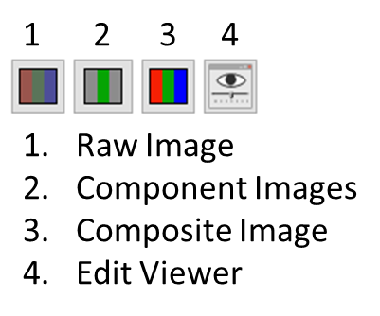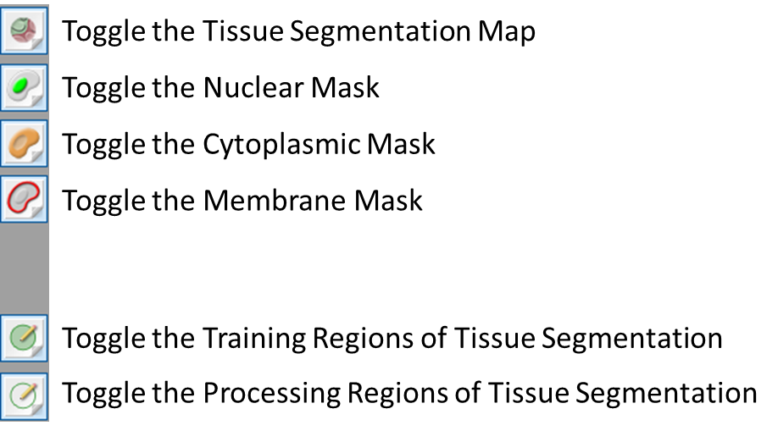

1. Adaptive Cell Segmentation
   1. Under the Segment Cells Module, Select [Add…] under Components and select DAPI
   2. Select […] next to DAPI to go to the DAPI configuration
   3. Under ‘Use this signal to find:’ select [Nuclei]
      1. A preview box outlined in red will display over your image. This box cannot be resized, but you can move around the red box if needed and zoom in and out with mouse wheel.
   4. Select […] next to DAPI to go to the DAPI configuration and will now see Typical Intensity (Relative) with a value of 0.60
      1. Adjust the value to capture as much nuclei as possible. At this point, do not worry about nuclei segmentation. The lower the value, the more sensitive it will pick up the stain. The higher the value, the more restrictive it will pick up the stain. Select [OK] when finished
         1. Look at the DAPI component image and toggle the nuclear mask to pick the intensity value. You can also add other nuclear markers (e.g. FoxP3) to aid in nuclear detection, but I often find that DAPI is sufficient enough. This also assumes that there is no bleed-through in the nuclear marker channel (e.g. Opal 540 bleeding into Opal 570) as well.
   5. Under Nuclear Component Splitting, select […] next to Splitting Sensitivity
      1. For My nuclei: select [A mixture of quality]
      2. Adjust the value (default of 0.9) of the nuclear splitting. Lower values allows for more aggressive nuclear splitting, whereas increasing the value merges nuclei together.
      3. Select [OK] when finished
   6. Under Other Settings, input a value for Fill Nuclear Holes Smaller Than:
      1. This option setting is useful for big nuclear cells (e.g. melanoma). The unit is in pixels.
   7. Check Refine cells after segmentation
   8. Under Segment, check mark Cytoplasm and Membrane
   9. Select [Add…]
      1. Add your membrane stains from most abundant to least abundant.
      2. Select […] and choose Membrane under ‘Use this signal to find’
      3. Check mark ‘Use this signal to assist in nuclear splitting’
   10. Under Assisting Component Splitting, select […] for Splitting Sensitivity
       1. Under ‘My assisting component staining is’, select [A mixture of quality]
       2. Adjust the splitting sensitivity value. Decrease the value to increase splitting sensitivity and increase the value to decrease splitting sensitivity.
       3. Adjust the ‘Minimum Nuclear Size’ to eliminate small cellular debris
   11. Under Membrane and Cytoplasm Settings, adjust the ‘Cytoplasm Thickness’. I usually choose 4.0 if looking at t-cells and even larger for tumor cells. This value should be smaller than ‘Membrane Search Distance’
   12. Adjust ‘Membrane Search Distance’. If you are only looking at small cells, then the value should be small. If looking at markers such as tumor or PDL1, the value should be higher.
   13. Select […] next to Membrane Signal Threshold
       1. Under ‘My membrane staining is’, select [A mixture of quality]
       2. Adjust the Membrane Signal Threshold. Lower the value to increase sensitivity and raise the value to decrease sensitivity.
   14. Assess your algorithm across multiple images and refine your algorithm by tweaking the values of the options above. It is a balance of finding over segmenting and under-segmenting.
   15. Save the project if this is the first antibody analyzed in this multiplex panel. This will allow you and other users to use the same tissue and cell segmentation (tumor may be the only exception that will have its own cell segmentation)
2. Phenotyping - Phenotyping requires Adaptive Cell Segmentation/Cell Segmentation
   1. Under the Phenotype Cells Module, select [Add…]
   2. Add the antibody name and choose a color
      1. Choose a color that will not be confusing with the color you chose for the library
      2. The name should correspond to the names defined in the ‘Target’ column of the BatchID file. The tumor marker, as indicated in column 14 (‘ImageQA\QC’) of that file, can be replaced with ‘Tumor’
   3. The second phenotype should be “Other” (I usually make this blue)
   4. Select  . Left click on a segmented cell, and a list of phenotypes you created will be shown.
      1. Select the correct phenotype for that cell
      2. Start by selecting 5 training cells per phenotype per case, focusing on phenotypes that are next to each other. This will help delineate neighboring cell types. Toggling on and off the channels and segmentation will aide in decision making as well.
   5. Once satisfied, select [Phenotype All]
   6. Quality check and add more training cells as needed
      1. Get a second opinion before saving
3. Export
   1. Select for following:
      1. For the lowest Opal in the primary segmentation (defined by the BatchID table) select Component Images (multi-image TIFF)
      2. For the lowest Opal of each segmentation type select binary_seg_maps.
      3. Cell Segmentation Data
4. Save
   1. File 🡪 Save 🡪 Project
   2. Save the Project & the algorithm to the \Clinical_Specimen_XX\tmp_inform_data\Projects_Development folder. If you do not save the project you will not be able to adjust the phenotyping
5. Repeat for all antibodies
   1. Make sure tissue segmentation is same across all Abs
   2. Change the segmentation for each additional segmentation type defined in the analysis
      1. usually the segmentation for immune cells but different for Tumor cells